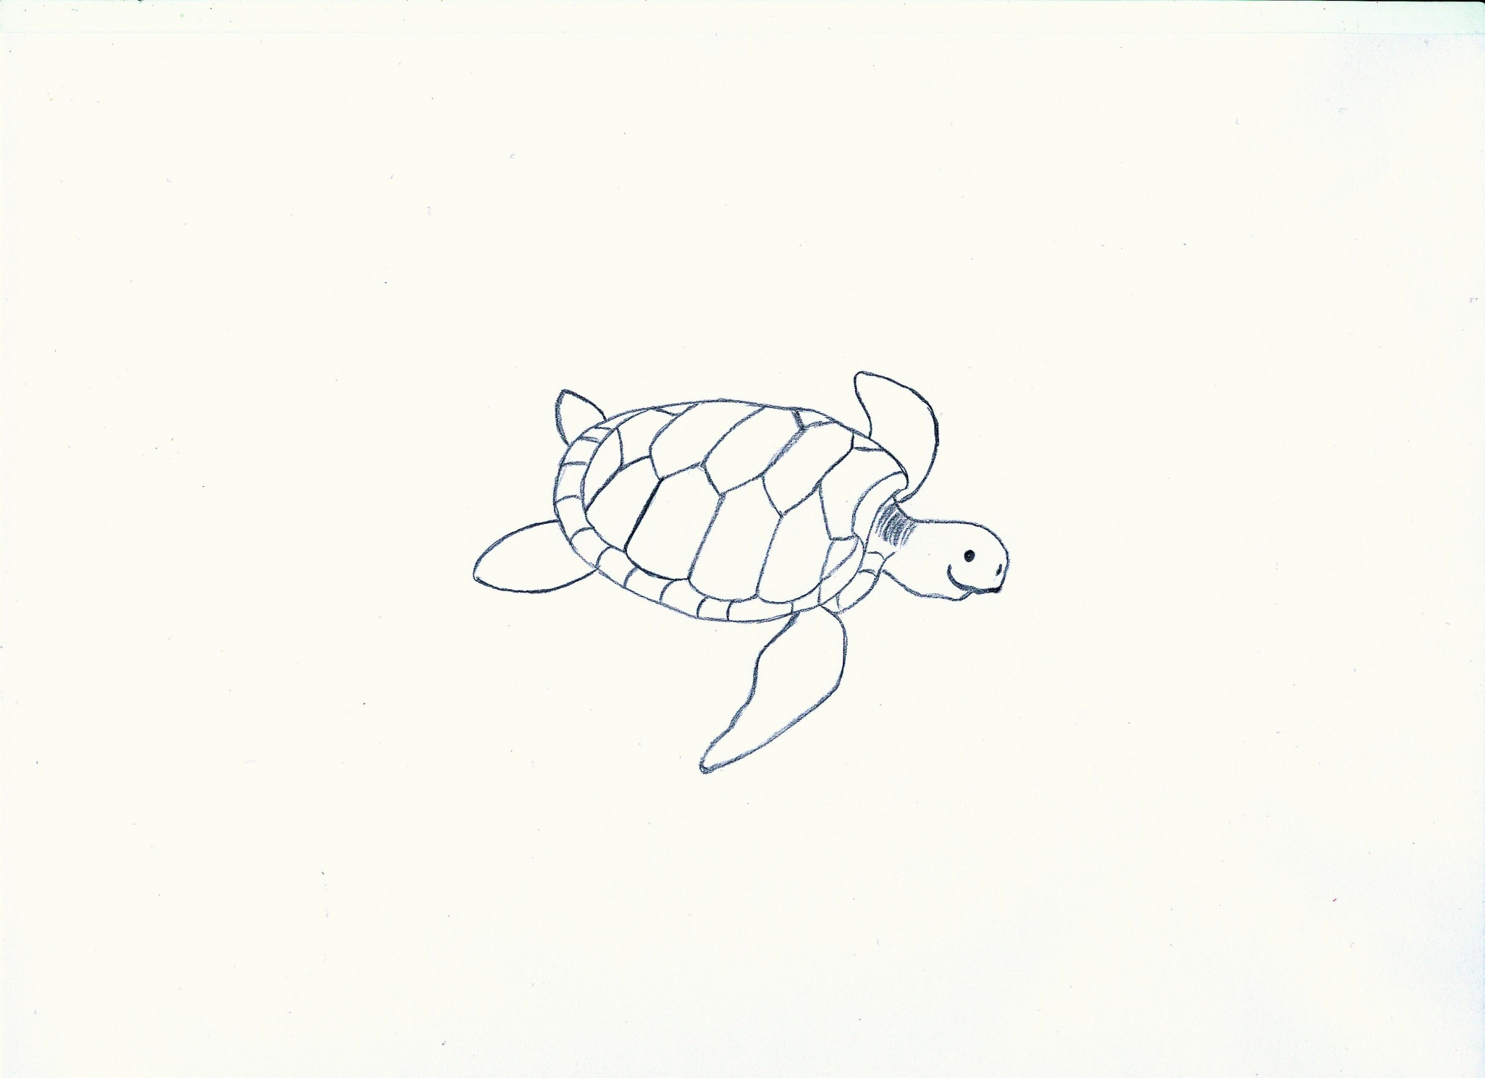

1.______________________________________ 2.__________________________________________

3.______________________________________ 4.__________________________________________

WS 2

**4**

domed carapace/ fins/ flat carapace/ mouth without teeth

**1**

**1**

**1**

**3**

**2**

**1**